Simulation Product Line

Research and Development

Fontys University

|  |
| --- |
| **Date : 16-09-2024** |
| **Version : 0001** |
| **Status : Status** |
| **Author : Joep van Dijk** |

#### Version

|  |  |  |  |  |
| --- | --- | --- | --- | --- |
| **Version** | **Date** | **Author(s)** | **Alterations** | **Status** |
| 0001 | 16-09-2024 | Joep van Dijk |  |  |
|  |  |  |  |  |
|  |  |  |  |  |
|  |  |  |  |  |
|  |  |  |  |  |
|  |  |  |  |  |
|  |  |  |  |  |
|  |  |  |  |  |
|  |  |  |  |  |
|  |  |  |  |  |
|  |  |  |  |  |
|  |  |  |  |  |

#### Distribution

|  |  |  |
| --- | --- | --- |
| **Version** | **Date** | **To** |
|  |  |  |
|  |  |  |

#### Contents

Use Case 1 4

Assignment 1 4

Assignment 2 5

Standard 5

Strategy 1 - Reduced repair time 5

Strategy 2 – buffer zones 7

Overall results 8

Use Case 2 9

Assignment 1 9

Assignment 2 10

Strategy 1 11

Strategy 2 13

Strategy 3 16

Strategy 4 18

Strategy 5 20

Results 23

Assignment 3 24

Research 25

Stochastics (random probability distribution) 25

Discrete distribution 25

Continuous distribution 25

Empirical Distribution 25

Queueing Theory 26

Experiments 26

Performance Measures (pfm) 26

Figure 1 - strategy 1 layout 7

Figure 2 - Experiment info strategy 1 8

Figure 3 - probability distribution strategy 4 9

Figure 4 - strategy 2 layout 10

Figure 5 - Label Number of groceries on atom 10

Figure 6 - server cycletime [s] 10

Figure 7 - Expirement info strategy 2 11

Figure 8 - Strategy 3 layout 12

Figure 9 - Source send conditional 12

Figure 10 - Experiment info strategy 3 - Exp timing 13

Figure 11 - Experiment info strategy 3 – Groceries Count 13

Figure 12 - strategy 4 layout 15

Figure 13 - Experiment info strategy 4 16

Figure 14 - Strategy 5 layout 17

Figure 15 - 4dScript queue entry and exit 17

Figure 16 - Trigger settings queue 18

Figure 17 - Experiment info strategy 5 19

Table 1 - info strategy 1 7

Table 2 - info strategy 2 10

Table 3 - info strategy 3 12

Table 4 - info strategy 4 15

Table 5 - info strategy 5 18

# Use Case 1

## Assignment 1

Calculated throughput

Lowest throughput bottleneck time per hour * hours per day * workdays

3 * 8 * 5 = 120

Loss of production = 10%

120 * 0,90 = 108 trailers per week

## Assignment 2

### Standard

#### Result

### A graph on a white background Description automatically generatedStrategy 1 - Reduced repair time

#### Result

### Strategy 2 – buffer zones



On the right side you can see the min a max waiting time between each of the server nodes. As you can see the transfer from server B to server C has a minimal transfer time of 1 minute. Because of that it has the highest priority to get a buffer to reduce transfer times. After that we look at the max possible transfer times. The transfer from server C to server D has the second max transfer time. So, this transfer has the second highest priority to get a buffer for transfer time reduction.

#### A graph on a white background Description automatically generatedResults

### Overall results

|  |  |
| --- | --- |
| Scenario | Week production |
| *Standard* | 95,98 |
| *Reduced repair* | 109,39 |
| *bufffer before c and D* | 105,99 |

# Use Case 2

## Assignment 1

*Analyse each strategy accurately. On the basis of (theoretical) utilizations, try to estimate which system will operate the most efficiently.*

My estimation will be that strategy 5 will operate the most efficient based on (theoretical) utilizations, because it won’t put valuable resources to use when it’s not completely necessary. All the other strategy’s make use of a fixed personnel utilization.

The strategy to change the service time on a per item basis won’t do allot in my estimation, because based on the probability distribution of “number of items per shopper” that was given. The average service time per customer, only on item basis, will roughly be the same as the service not on item basis. And when you add the payment time, I estimate the time will be a bit longer.

## Assignment 2

*Build simulation models for all strategies and define for each the average queue and waiting time (in strategy 3 for both customer types).*

checkouts open on Saturday from 9:00 to 17:00

average 1400 shoppers in a day (random distribution)

To write the correct 4dScript for the Interval-arrival Time in the Source Node I must calculate the average time between the shoppers. To do this I get the total time the shop is open and divide it by the number of shoppers. To get the random distribution of shoppers during the day I will use the negative Exponential over the average Interval-arrival Time between the shoppers.

The shop is open for 8 hours. That is a total of 3600*8 seconds = 28800 seconds

Now I will divide the open hours by the number of shoppers

28800 / 1400 ≈ 20,57 seconds

To determine the best stochastic distribution for modeling customer service, I conducted some research. I found that the Poisson distribution is widely used due to its memoryless property, meaning the probability of a new customer arriving is independent of the time since the last customer arrived. Additionally, the Poisson distribution maintains a consistent average arrival rate, making it a reliable choice for such modeling.

The final 4dScript for the Interval-arrival Time will be “Poisson(20,57)”.



Figure 2 - Source node

### Strategy 1

(fixed personnel, service time independent on the number of groceries)

In this case, all checkouts are open and the service time for each customer is taken from a negative exponential distribution with an average of 2.5 minutes

#### layout

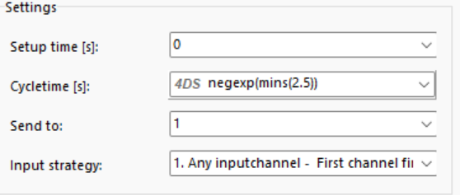Figure 1 - strategy 1 layout

Figure 3 - Checkout node

#### Experiment information

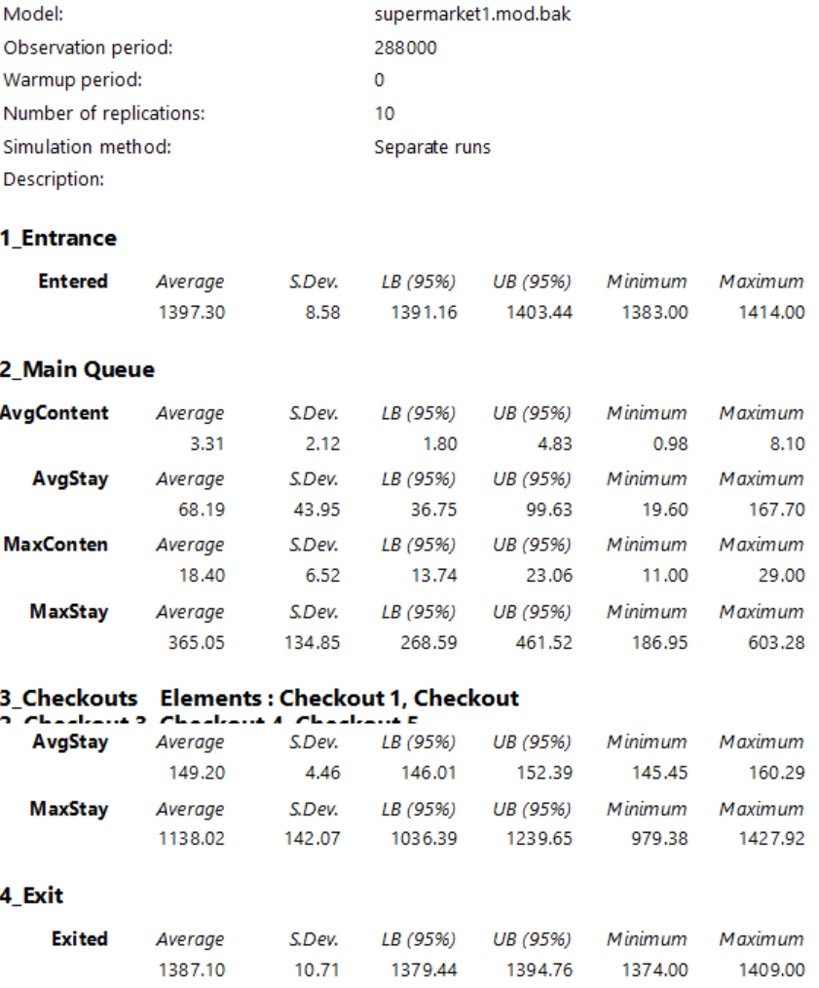

Figure 2 - Experiment info strategy 1

|  |  |  |  |
| --- | --- | --- | --- |
|  | Avg Checkout Stay (seconds) | Avg Queue length  (Customers) | Avg Queue Stay  (seconds) |
| Strategy 1 | 149.20 | 3.31 | 68.19 |

Table 1 - info strategy 1

### Strategy 2

(fixed personnel, service time dependent on the number of groceries)

This is a variation of the first strategy where the service time depends on the number of items purchased. We assume that the scanning time per item is 6 seconds, and that payment takes 30 seconds.

Measurements have shown that the following empirical probability distribution can be used for the number of groceries:

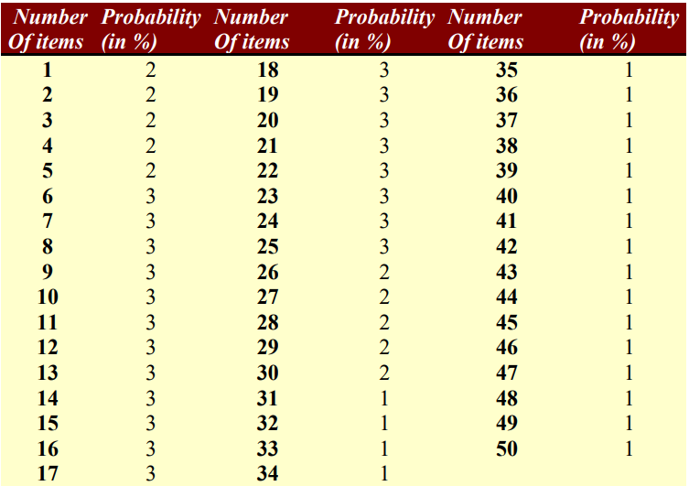

Figure 3 - probability distribution strategy 4

#### Layout

Figure 4 - strategy 2 layout

Figure 5 - Label Number of groceries on atom



Figure 6 - server cycletime [s]

#### Experiment information

Figure 7 - Expirement info strategy 2

|  |  |  |  |
| --- | --- | --- | --- |
|  | Avg Checkout Stay (seconds) | Avg Queue length  (Customers) | Avg Queue Stay  (seconds) |
| Strategy 2 | 153.33 | 1.33 | 27.38 |

Table 2 - info strategy 2

### Strategy 3

(fixed personnel, service time dependent on the number of groceries and separation of customer types)

In this strategy, the first checkout is an express lane: only customers with 10 items or less are allowed to use this checkout. In this case, we assume that all these customers will actually use the express lane

#### Layout

Figure 8 - Strategy 3 layout

Figure 9 - Source send conditional

#### A screenshot of a table Description automatically generatedExperiment information

Figure 10 - Experiment info strategy 3 - Exp timing

Figure 11 - Experiment info strategy 3 – Groceries Count

|  |  |  |  |
| --- | --- | --- | --- |
|  | Avg Checkout Stay (seconds) | Avg Queue length  (Customers) | Avg Queue Stay  (seconds) |
| Strategy 3  Groceries-Count* | 152.34 | 4.44 | 91.18 |
| Strategy 3  Exp-Timing* | 151.43 | 62.65 | 852.45 |

Table 3 - info strategy 3

*Groceries-Count – The checkout time is based on the number of groceries

*Exp-Timing – the checkout time is based on negative exponential distribution

### Strategy 4

(fixed personnel, service time dependent on the number of groceries, with priority to the customers with the least groceries)

This alternative is interesting from the point of view of flows, but would lead to major problems in supermarkets. Modify the second model so that customers with the fewest items are served first

#### Layout

Figure 12 - strategy 4 layout

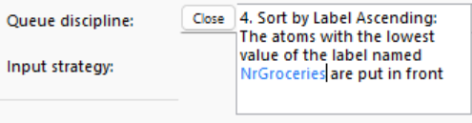

#### Experiment information

Figure 13 - Experiment info strategy 4

|  |  |  |  |
| --- | --- | --- | --- |
|  | Avg Checkout Stay (seconds) | Avg Queue length  (Customers) | Avg Queue Stay  (seconds) |
| Strategy 4 | 153.55 | 1.03 | 20.99 |

Table 4 - info strategy 4

### Strategy 5

(variable personnel, service time dependent on the number of people waiting)

The availability of checkouts is now linked to the number of customers in the queue: if 0 to 3 customers are waiting, checkout 1 opens, 4 to 6 customers, checkout 2 etc. up to a total of 8 checkouts for 22 customers or more. When the number of customers queuing decreases, the corresponding number of checkouts closes

#### Layout

Figure 14 - Strategy 5 layout

Figure 15 - 4dScript queue entry and exit

Figure 16 - Trigger settings queue

#### Experiment information

Figure 17 - Experiment info strategy 5

|  |  |  |  |
| --- | --- | --- | --- |
|  | Avg Checkout Stay (seconds) | Avg Queue length  (Customers) | Avg Queue Stay  (seconds) |
| Strategy 5 | 150.85 | 20.38 | 423.49 |

Table 5 - info strategy 5

### Results

|  |  |  |  |  |  |  |
| --- | --- | --- | --- | --- | --- | --- |
|  | Strategy 1 | Strategy 2 | Strategy 3 | | Strategy 4 | Strategy 5 |
| Groc-Count | Exp-Time |
| Queues | | | | | | |
| **Avg Content**  **(customers)** | 3.31 | 1.33 | 4.44 | 62.65 | 1.03 | 20.38 |
| **Avg Stay**  **(seconds)** | 68.19 | 27.38 | 91.18 | 852.45 | 20.99 | 423.49 |
| **Max Content**  **(customers)** | 18.40 | 8.80 | / | / | 6.70 | 35.80 |
| **Max Stay (seconds)** | 365.05 | 165.50 | 397.40 | 11342.99 | 830.50 | 726.66 |
| Checkouts | | | | | | |
| **Avg Stay**  **(seconds)** | 149.20 | 153.33 | 152.34 | 151.43 | 153.55 | 150.85 |
| **Max Stay**  **(seconds)** | 1387.10 | 330.00 | 330.00 | 1141.50 | 330.00 | 1148.78 |

|  |  |
| --- | --- |
| Strategy Explained* | |
| Strategy 1 | * server time negExp(min(2.5)) |
| Strategy 2 | * server time depends on amount of items   item = 6 seconds  payment = 30 seconds |
| Strategy 3 | * service time depends on amount of items   item = 6 seconds  payment = 30 seconds   * express lane for items <= 10 |
| Strategy 4 | * service time depends on amount of items   item = 6 seconds  payment = 30 seconds   * least items first out |
| Strategy 5 | * server time negExp(min(2.5)) * variable checkouts   1 open = 0 < customers <= 3  2 open = 3 < customers <= 6  3 open = 6 < customers <= 9  4 open = 9 < customers <= 12  5 open = 12 < customers <= 15  6 open = 15 < customers <= 18  7 open = 18 < customers <= 21  8 open = 21 < customers |

*

- 8 checkout lanes

- checkouts open on Saturday from 9:00 to 17:00

- average 1400 shoppers in a day (random)

-fifo

-checkout operators work with the same speed

(I use poisson distribution for the random distribution of shoppers)

## Assignment 3

*Which system would you recommend? Can they be compared with each other? Are*

*there better alternatives?*

When I look at the results of the different strategies, I deduct that the different strategies in service time is negligible in the case of average service time. But the standard deviation is considerably higher when using the negative exponential distribution compared to the empirical distribution with the number of items. I assume that these higher deviations have a correlation with the extended average staying times in the queue.

I would recommend using the empirical distribution in case of service times.

Looking at the different strategies with the use of the empirical distribution. I deduct that strategy 3 has a significant higher queueing time compared to strategy 2 and strategy 4. This make me want to rule out strategy 3 and the use of a fast lane, because I don’t see a significant benefit from it.

Strategy 4, which prioritizes customers with fewer items by placing them at the front of the queue, results in the shortest average queueing time. However, it also produces significant outliers. In contrast, Strategy 2, which follows a first-in, first-out (FIFO) approach, is more consistent, showing a substantial reduction in outliers.

I recommend using strategy 2. It doesn’t significantly punish the queueing time of the customer on the number of items bought and it is very stable. If the punishment of customers with a larger number of groceries is not a problem, then go for strategy 4 with the lower overall stay time.

## Conclusion

Figure 18 - Answer results

I notice that the results of the given answers are very different compared to the result I found. Only the results from strategy 5 are comparable.

I found that the reason for this difference is the stochastic distribution that is used for the Inter-arrival time. When I change the inter-arrival time to a negative exponential distribution the resulted values are similar.

I used the poisson distribution for the simulation, because the simulated process is a M/M/c queueing model. And I found that this is the most commonly used stochastic distribution for this type of queueing model, mainly because of it’s memoryless property.

# Use Case 3

## Assignment 1

*Make your own calculation / reasoned estimate beforehand regarding the transport system capacity in the case of an equal production per machine (in boxes per hour). Where will the system first jam?*

In my estimated calculations regarding system capacity per hour I’m going to disregard if there will be any jams, because of the difficulty of calculating this.

The conveyor speed is 1m/s

The distance from machine 1 to the first conveyor switch and each conveyor switch respectively is 10 meters.

This means that each segment on the main conveyor belt takes 10 seconds.

Process time:

Machine line 1 : 0 sec

machine line 2 : 2 sec

machine line 3 : 2 sec

machine line 4 ; 10 sec

machine line 5 : 5 sec

Conveyor time:

Machine line 1 : 50 sec

Machine line 2 : 45 sec

Machine line 3 : 35 sec

Machine line 4 : 25 sec

Machine line 5 : 15 sec

Conveyor switch 3 has the largest process time per box, because of that I

# Research

## Stochastics (random probability distribution)[1]

Stochasticity refers to the modeling approach of the phenomenon of randomness. But these terms are often used synonymously. Stochastics are often used in probability theory.

Enterprise Dynamics has several built-in stochastic math functions to simulate randomness.

### Discrete distribution

A discrete distribution applies to a discrete random variable, which can take on a countable set of distinct values. These values can be whole numbers or other countable data points, such as the number of heads in coin tosses, or the number of students in a class.

#### Poisson distribution[2]

The Poisson process is a stochastic process with several definitions and applications. It’s a counting process, which is a stochastic process in which a random number of points or occurrences are displayed over time. A time-dependent Poisson random variable is defined as the number of points in a process that falls between zero and a certain time. Non-negative numbers make up the index set of this process, but natural numbers make up the state space. Because it can be conceived of as a counting operation, this procedure is often referred to as the Poisson counting process.

The poisson process is a non-negative discrete distribution

### Continuous distribution

A continuous distribution applies to a continuous random variable, which can take on an infinite number of values within a given range. These values are not countable because they include every possible number between any two points.

#### Negative Exponential distribution

### Empirical Distribution

An empirical distribution refers to a probability distribution that is based directly on observed data rather than on a theoretical model. It is used to describe the distribution of a set of observed values, showing the relative frequencies of outcomes in the data.

## Queueing Theory

## Experiments[3]

### Performance Measures (pfm)

#### Groups

The average stay for group experiments is calculated on a weighted basis of total output. This is done to remove biases of different elements in the group with a lower output.

1. InControl Enterprise Dynamics [Computer program]**.** (2023). *HTML Help 4DScript category stochastic*. InControl Enterprise Dynamics.

   Bartholomew, D. J. (2015). *Stochastic models. In Elsevier eBooks (pp. 467–472).* [*https://doi.org/10.1016/b978-0-08-097086-8.43095-3*](https://doi.org/10.1016/b978-0-08-097086-8.43095-3)

   Young, J. (2024, May 31). *Discrete Probability Distribution: Overview and examples*. Investopedia. <https://www.investopedia.com/terms/d/discrete-distribution.asp>

   OpenAI. (2024). *ChatGPT* (Sep 19 version) [Large language model]. <https://chat.openai.com/chat>
2. Lendave, V. (2024, July 15). *A guide to stochastic Process and its applications in machine learning*. AIM. <https://analyticsindiamag.com/developers-corner/a-guide-to-stochastic-process-and-its-applications-in-machine-learning/>
3. InControl Simulation Solutions. (2023, November 14). *Experimentation: Enterprise Dynamics 10 (Version 10). InControl Simulation Solutions.* [*https://www.incontrolsim.com*](https://www.incontrolsim.com)